**Training Report**

cev

HTML

1)Paragraph

The HTML <p> element defines a paragraph.

Formatting elements were designed to display special types of text:

<b> - Bold text, <strong> - Important text, <i> - Italic text, <em> - Emphasized text, <mark> - Marked text, <small> - Smaller text, <del> - Deleted text, <ins> - Inserted text, <sub> - Subscript text, <sup> - Superscript text.

2)Links

The HTML <a> tag defines a hyperlink. The most important attribute of the <a> element is the ‘href’ attribute, which indicates the link's destination. The target attribute specifies where to open the linked document. The target attribute can have one of the following values:

_self - Default. Opens the document in the same window/tab as it was clicked,

_blank - Opens the document in a new window or tab,

_parent - Opens the document in the parent frame,

_top - Opens the document in the full body of the window

3)Image

The HTML <img> tag is used to embed an image in a web page. It has two attributes:-

src - Specifies the path to the image

alt- Specifies an alternate text for the image

You can use the <style> attribute to specify the width and height of an image.

Alternatively, you can use the ‘width’ and ‘height attributes.

4)Image Map

The image is inserted using the <img> tag. The only difference from other images is that you must add a ‘usemap’ attribute. The ‘usemap’ value starts with a hash tag ‘#’ followed by the name of the image map, and is used to create a relationship between the image and the image map. Then, add a <map> element and ‘name’ attribute. The name attribute must have the same value as the <img>'s ‘usemap’ attribute . Then add clickable areas. A clickable area is defined using an <area> element. The area can be:-

rect - defines a rectangular region, circle - defines a circular region,

poly - defines a polygonal region, default - defines the entire region

Then set its coordinates and the link to site using ‘href’

5)Picture Element

The HTML <picture> element allows you to display different pictures for different devices or screen sizes.

The <picture> element contains one or more <source> elements, each referring to different images through the ‘srcset’ attribute. This way the browser can choose the image that best fits the current view and/or device.

Each <source> element has a ‘medis’ attribute that defines when the image is the most suitable.

6)Lists

An unordered list starts with the <ul> tag. Each list item starts with the <li> tag.

An ordered list starts with the <ol> tag. Each list item starts with the <li> tag.

A description list is a list of terms, with a description of each term.

The <dl> tag defines the description list, the <dt> tag defines the term (name), and the <dd> tag describes each term.

7)IFrames

An HTML iframe is used to display a web page within a web page. The HTML <iframe> tag specifies an inline frame. Use the ‘height’ and ‘width’ attributes to specify the size of the iframe. An iframe can be used as the target frame for a link. The ‘target’ attribute of the link must refer to the ‘name’ attribute of the iframe. Use ‘border:none; ‘ to remove the border around the iframe

CSS

CSS stands for Cascading Style Sheets. CSS describes how HTML elements are to be displayed on screen, paper, or in other media. CSS saves a lot of work. It can control the layout of multiple web pages all at once. External stylesheets are stored in CSS files.

1)Comments

A CSS comment is placed inside the <style> element, and starts with /* and ends with */.

2)Colors (RGB value)

In CSS, a color can be specified as an RGB value, using this formula:

**rgba(*red,* *green*, *blue, alpha*).** Each parameter (red, green, and blue) defines the intensity of the color between 0 and 255 and alpha means opacity ( between 0 and 1 ).

3)Backgrounds

The CSS background properties are used to add background effects for elements.

The ‘background-color’ property specifies the background color of an element.

The ‘background-color’ property specifies an image to use as the background of an element.( background-image=url(‘’); ).

The ‘background-attachment‘property specifies whether the background image should scroll or be fixed (will not scroll with the rest of the page).

4)Borders

The ‘border-style’ property specifies what kind of border to display.

dotted - Defines a dotted border

dashed - Defines a dashed border

solid - Defines a solid border

double - Defines a double border

groove - Defines a 3D grooved border. The effect depends on the border-color value

none - Defines no border

The ‘border-width’ property specifies the width of the four borders (in px, pt, cm, em, etc)

The ‘border-color’ property is used to set the color of the four borders using RGB or HEX values.

5)Margins

The CSS ‘margin’ properties are used to create space around elements, outside of any defined borders. It is set in px or %.

margin-top, margin-right, margin-bottom, margin-left.

Similar approach for padding.

6)Text

The ‘color’ property is used to set the color of the text.

The ‘text-align’ property is used to set the horizontal alignment of a text.

The ‘text-align-last’ property specifies how to align the last line of a text.

The ‘direction’ and ‘Unicode-bidi’ properties can be used to change the text direction of an element.

The ‘text-decoration-line’ property is used to add a decoration line to text like overline, underline, line-through or overline underline.

The ‘text-decoration-color’ property is used to set the color of the decoration line.

The text-deocration property is a shorthand property for:

Text-decoration-line (required)

Text-decoration-color (optional)

Text-decoration-style (optional)

Text-decoration-thickness (optional)

The ‘text-transform’ property is used to specify uppercase and lowercase letters in a text.

7)Links

Links can be styled with any CSS property

The four links states are:

a:link - a normal, unvisited link, a:visited - a link the user has visited,

a:hover - a link when the user mouses over it, a:active - a link the moment it is clicked

The ‘text-decoration’ property is mostly used to remove underlines from links.

The ‘background-color’ property can be used to specify a background color for links.

8)Lists

The ‘list-style-type’ property specifies the type of list item marker like circle, square, upper-roman, etc.

The list-style-image’ property specifies an image as the list item marker.

The ‘list-style’ property is a shorthand property. It is used to set all the list properties in one declaration.

9)Tables

To specify table borders in CSS, use the ‘border’ property.

Add ‘width :100%’ to the <table> element for full width table.

The width and height of a table are defined by the ‘width’ and ‘height’ properties.

Add the ‘border-bottom’ property to <th> and <td> for horizontal dividers.

Use the ‘:hover’ selector on <tr> to highlight table rows on mouse over.

Bootstrap

Bootstrap is a free front-end framework for faster and easier web development. Bootstrap includes HTML and CSS based design templates for typography, forms, buttons, tables, navigation, modals, image carousels and many other, as well as optional JavaScript plugins. Bootstrap also gives you the ability to easily create responsive designs

1)Containers

Containers are used to pad the content inside of them, and there are two container classes available:

1. The ‘.container’ class provides a responsive **fixed width container**
2. The ‘.container-fluid’ class provides a **full width container**, spanning the entire width of the viewport

2)Grids

Bootstrap's grid system is built with flexbox and allows up to 12 columns across the page. The grid system is responsive, and the columns will re-arrange automatically depending on the screen size. Grid system has six classes:

* .col- (extra small devices - screen width < 576px)
* .col-sm- (small devices - screen width >= 576px)
* .col-md- (medium devices - screen width >= 768px)
* .col-lg- (large devices - screen width >= 992px)
* .col-xl- (xlarge devices - screen width >= 1200px)
* .col-xxl- (xxlarge devices - screen width >= 1400px)

3)Table

A basic Bootstrap 5 table has a light padding and horizontal dividers.

The ‘.table’ class adds basic styling to a table.

The ‘.table-striped’  class adds zebra-stripes to a table.

The ‘.table-bordered’  class adds borders on all sides of the table and cells.

The ‘.table-sm’  class makes the table smaller by cutting cell padding in half.

The ‘.table-responsive’  class adds a scrollbar to the table when needed (when it is too big horizontally).

The ‘.table-hover’  class adds a hover effect (grey background color) on table rows.

Contextual Classes can be used to color the whole table (<table>),  the table rows (<tr>) or table cells (<tr>).

4)Images

The ‘.rounded’ class adds rounded corners to an image.

The ‘.rounded-circle’ class shapes the image to a circle.

The ‘.img-thumbnail’ class shapes the image to a thumbnail (bordered).

Float an image to the left with the ‘.float-start’ class or to the right with ‘.float-end’.

The ‘.img-fluid’ class applies ‘max-width:100%;’ and ‘height:auto’ to the image and makes it responsive.

5)Navs

If you want to create a simple horizontal menu, add the ‘.nav’ class to a <ul> element, followed by ‘.nav-item’ for each <li> and add the ‘.nav-link’ class to their links:

Add the ‘.flex-column’ class to create a vertical nav.

Turn the nav menu into navigation tabs with the ‘.nav-tabs’ class. Add the ‘.active’ class to the active/current link.

Turn the nav menu into navigation pills with the ‘.nav-pills’ class.

To make the tabs toggleable, add the ‘data-bs-toggle=”tab”' attribute to each link. Then add a ‘.tab-pane’ class with a unique ID for every tab and wrap them inside a <div> element with class ‘.tab-content’. If you want the tabs to fade in and out when clicking on them, add the .fade class to ‘.tab-pane’. Same goes for nav-pills, add ‘ data-bs-toggle=”pill” ‘.

6)Navbar

A navigation bar is a navigation header that is placed at the top of the page.

A standard navigation bar is created with the ‘.navbar’ class, followed by a responsive collapsing class: ‘.navbar-expand-xxl|xl|lg|md|sm.

To add links inside the navbar, use either an <ul> element (or a <div>) with ‘class=”navbar-nav”. Then add <li> elements with a ‘.nav-item’ class followed by an <a> element with a ‘.nav-link’ class.

Remove the ‘.navbar-expand-*’ class to create a navigation bar that will always be vertical.

Use any of the ‘.bg-color’ classes to change the background color of the navbar.

The ‘.navbar-brand’ class is used to highlight the brand/logo/project name of your page.

Navbars can also hold dropdown menus.

You can also include forms inside the navigation bar.

The ‘.fixed-top’ class makes the navigation bar fixed at the **top**. Which remains at top independent of scrolling.

Use the ‘.fixed-bottom’ class to make the navbar stay at the **bottom** of the page.

7)Carousel

The Carousel is a slideshow for cycling through elements:

‘.carousel’ creates a carouosel.

‘.carousel-indicators’ adds indicators for the carousel. These are the little dots at the bottom of each slide (which indicates how many slides there are in the carousel, and which slide the user are currently viewing)

‘.carousel-inner’ adds slides to the carousel.

‘.carousel-item’ specifies the content of each slide.

‘.carousel-control-prev’ adds a left (previous) button to the carousel, which allows the user to go back between the slides.

‘.carousel-control-next’ adds a right (next) button to the carousel, which allows the user to go forward between the slides.

‘.carousel-control-prev-icon’ is used together with .carousel-control-prev to create a "previous" button.

‘.carousel-control-next-icon’ is used together with .carousel-control-next to create a "next" button.

Add elements inside the <div class=”carousel-caption”> within each <div class=”carousel-item”> to create a caption for each slide.

8)Colors

Bootstrap has some contextual classes that can be used to provide "meaning through colors".

The classes for text colors are: ‘.text-muted’, ‘.text-primary’, ‘.text-success’, ‘.text-info’, ‘.text-warning’, ‘.text-danger’, ‘.text-secondary’, ‘.text-white’, ‘.text-dark’, ‘.text-body’ (default body color/often black) and ‘.text-light’.

The classes for background colors are: ‘.bg-primary’, ‘.bg-success’, ‘.bg-info’, ‘.bg-danger’, ‘.bg-warning’, ‘.bg-secondary’, ‘.bg-dark’ and ‘.bg-light’.

8)Utilities

Float an element to the right with the ‘.float-end’ class or to the left with ‘.float-start’, and clear floats with the ‘.clearfix’ class.

Use the border classes to add or remove borders from an element:

Use ‘.border-1’ to ‘.border-5’ to change the width of the border:

Add a color to the border with any of the contextual border color classes:

Set the width of an element with the w-* classes (.w-25, .w-50, .w-75, .w-100, .mw-100, .mw-auto). Same with the height class ( .h-* )

m sets margin, p sets padding. t sets margin-top (mt-*), b sets margin-bottom(mb-*), s sets margin-left (ms-*), e sets margin-right(me-*), x sets margin-left and margin-right (mx-*), y sets margin-top and margin-bottom (my-*), blank sets margin on all four sides (m-*)

where * stands for size which is one of:-

0 for nothing, 1 for margin to .25rem, 2 for margin to .5rem, 3 for margin to 1rem, 4 for margin to 1.5rem, 5 to margin to 3rem and sets margin to auto.

Similarly for padding ( replace m wit p ).

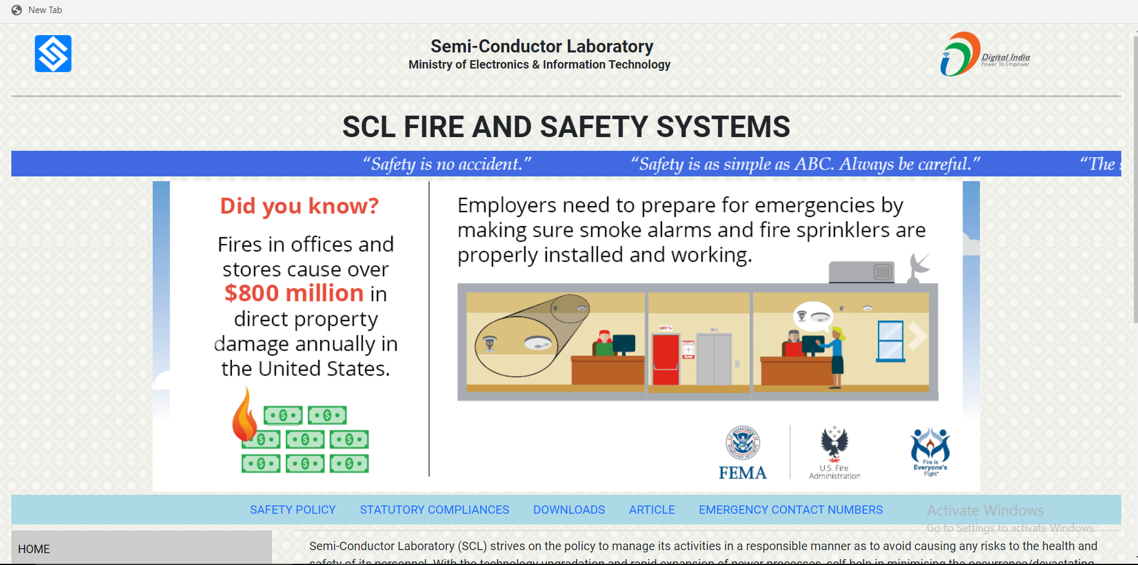

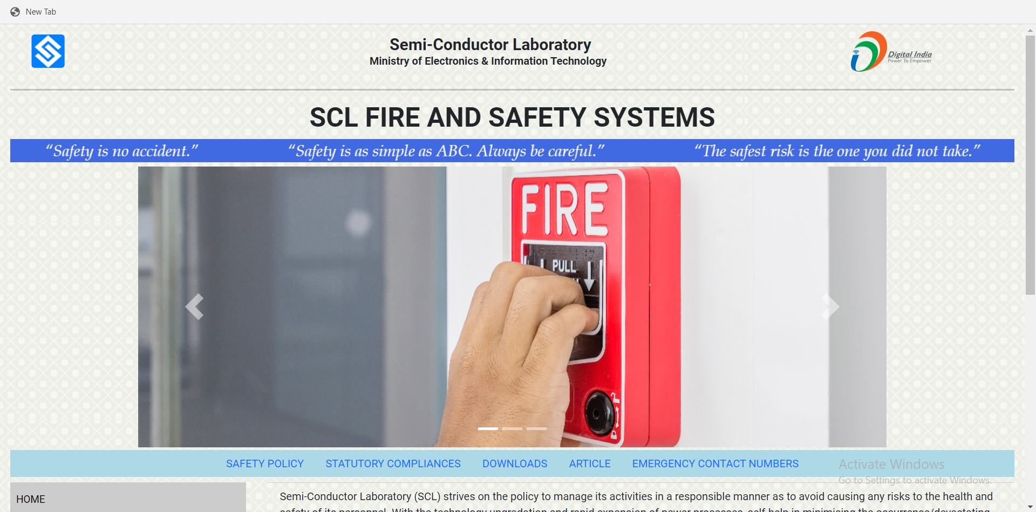

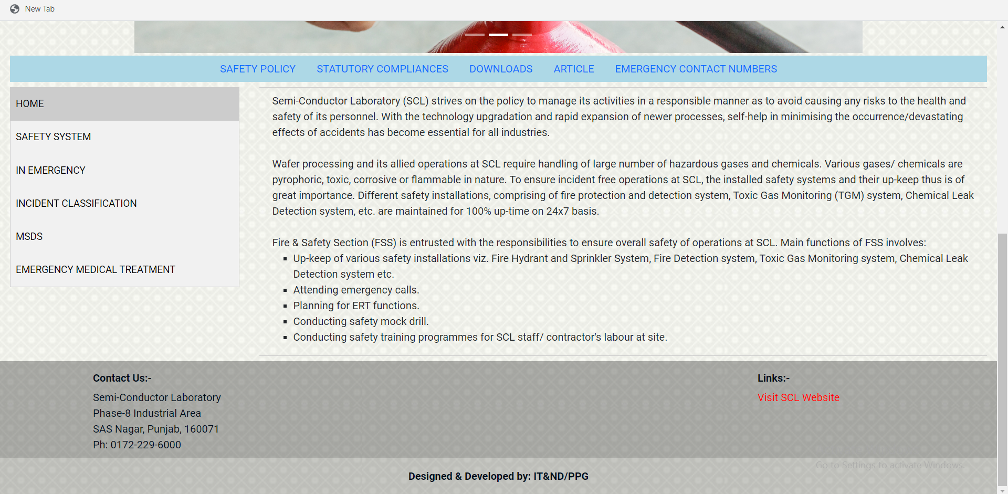

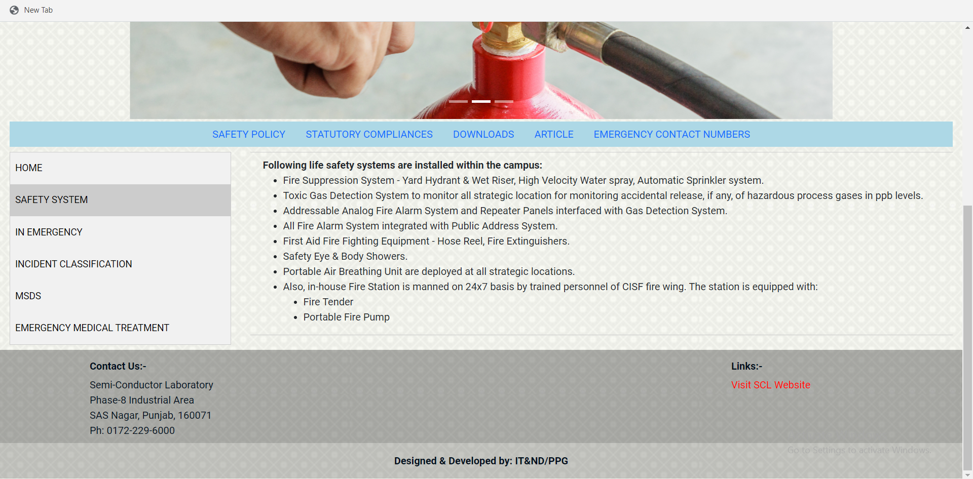

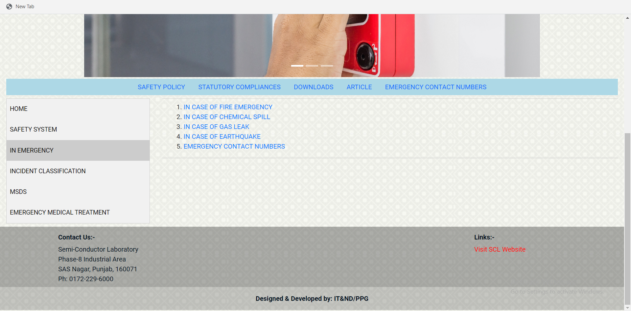

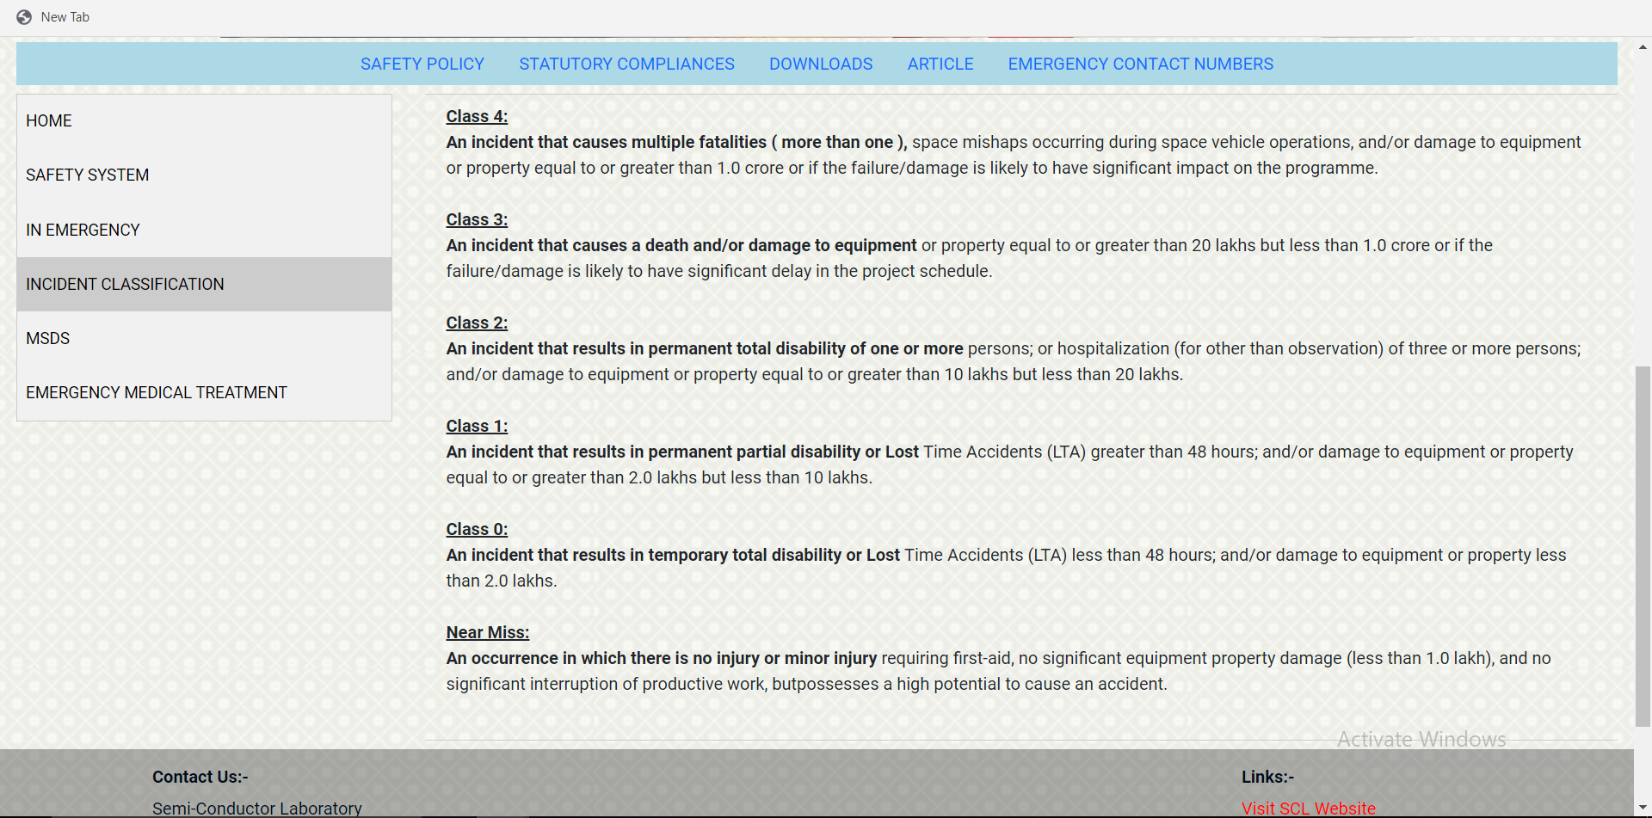

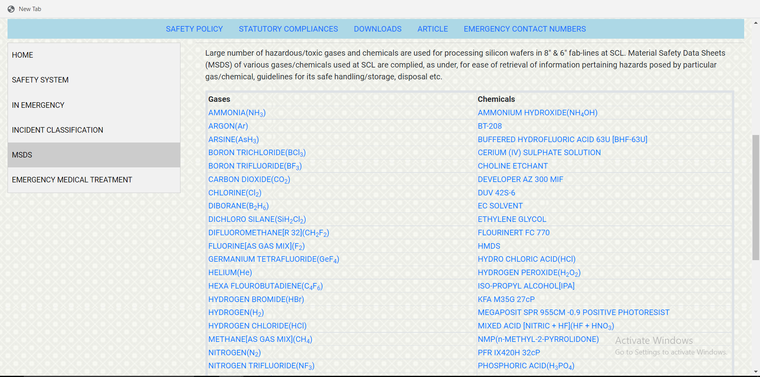

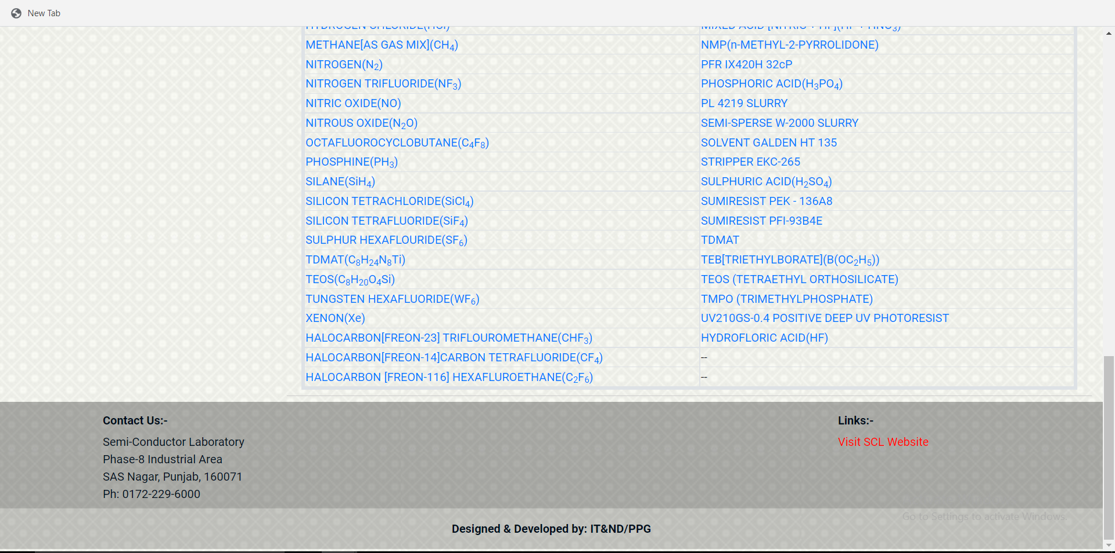

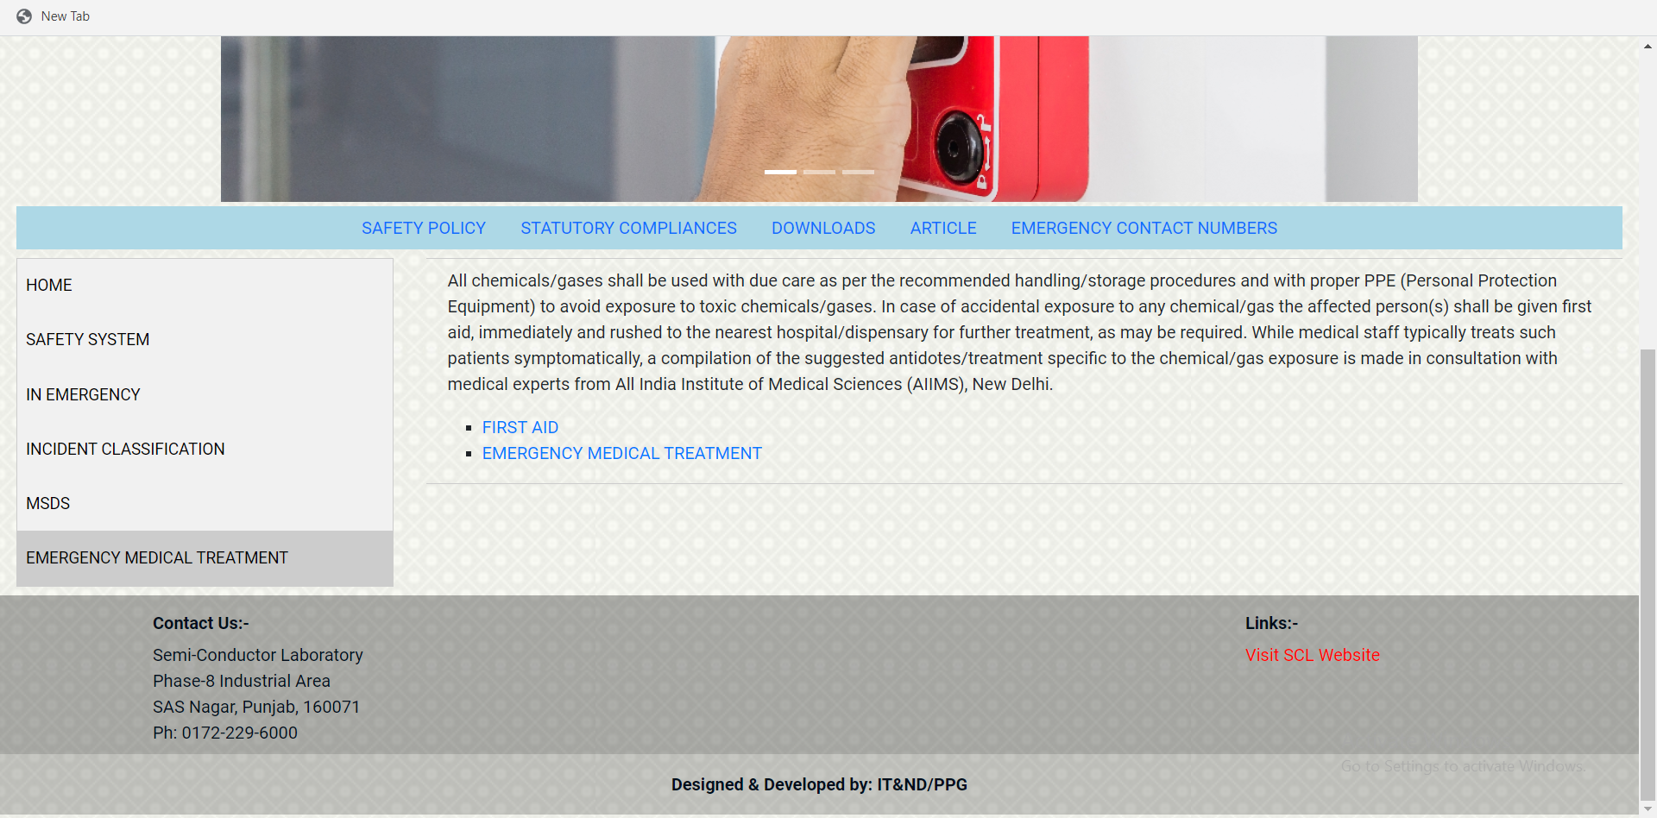

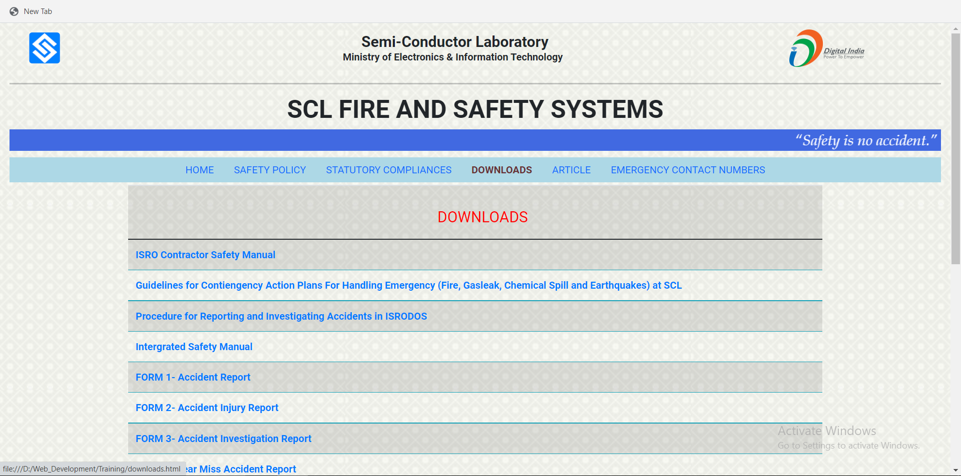

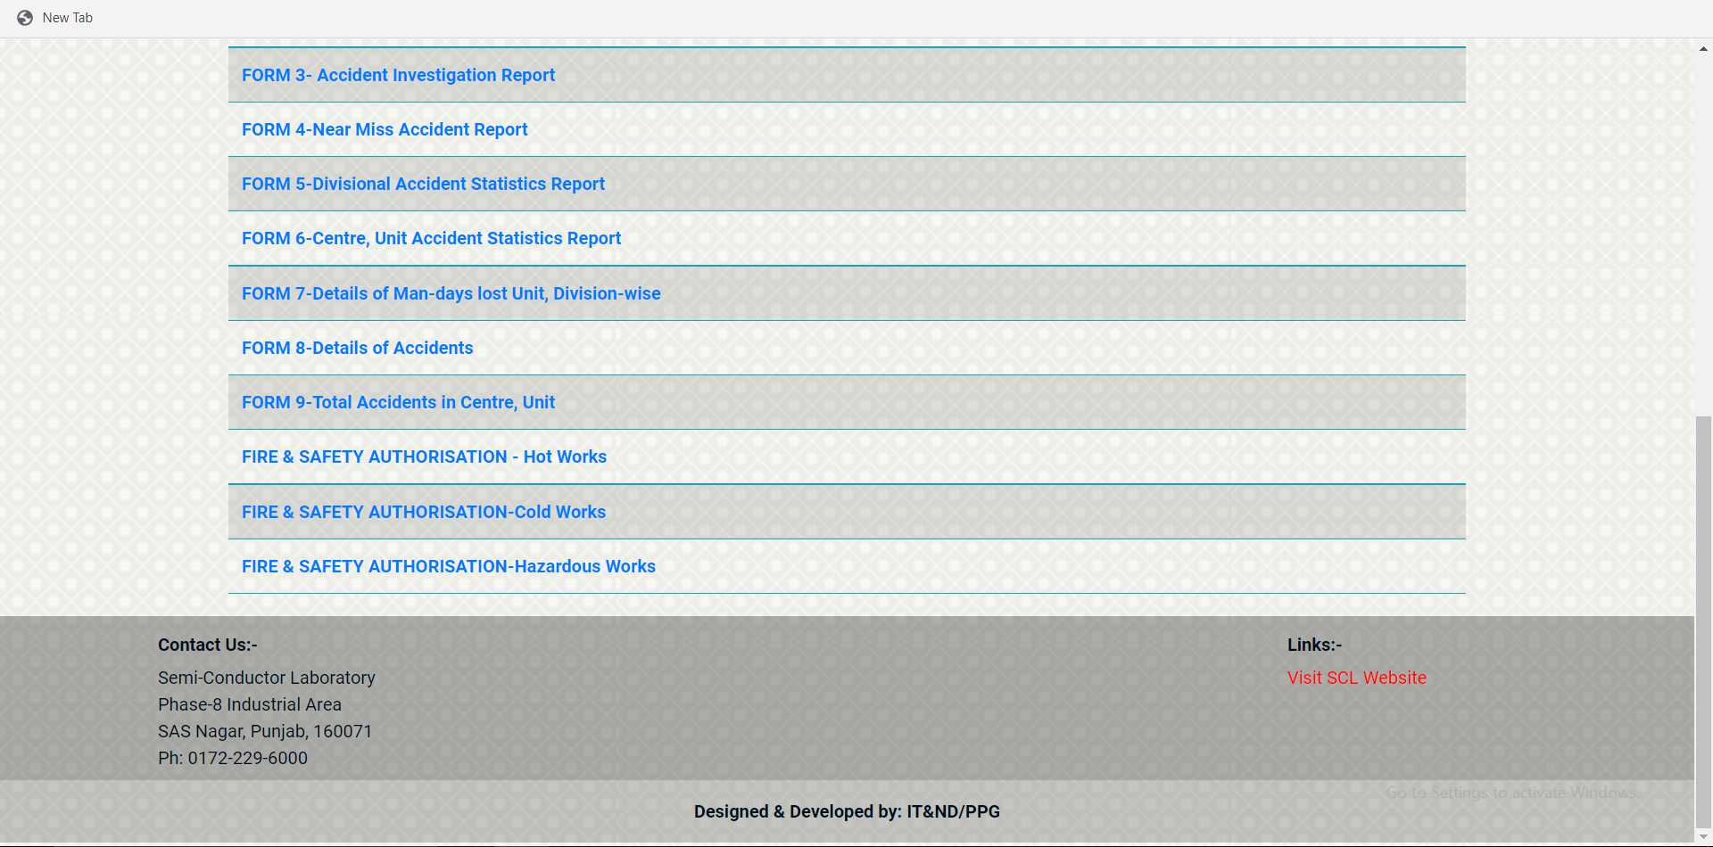

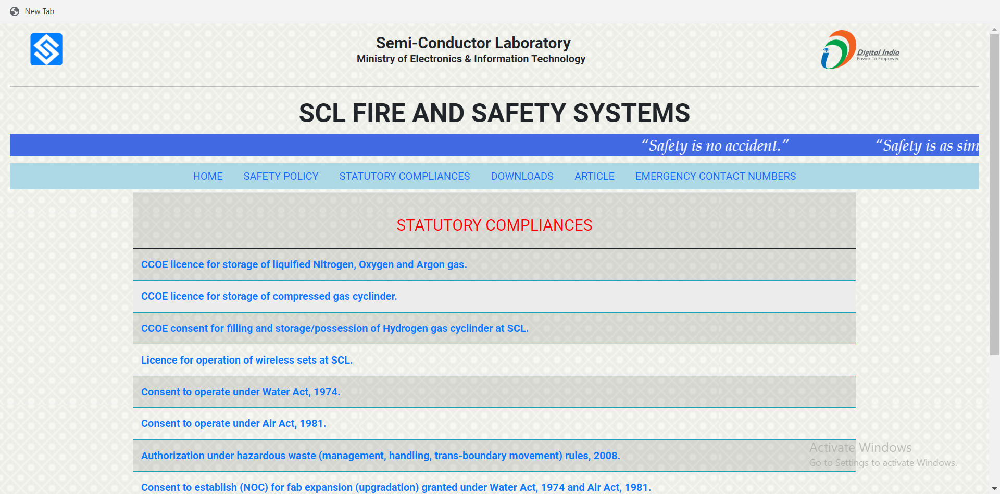

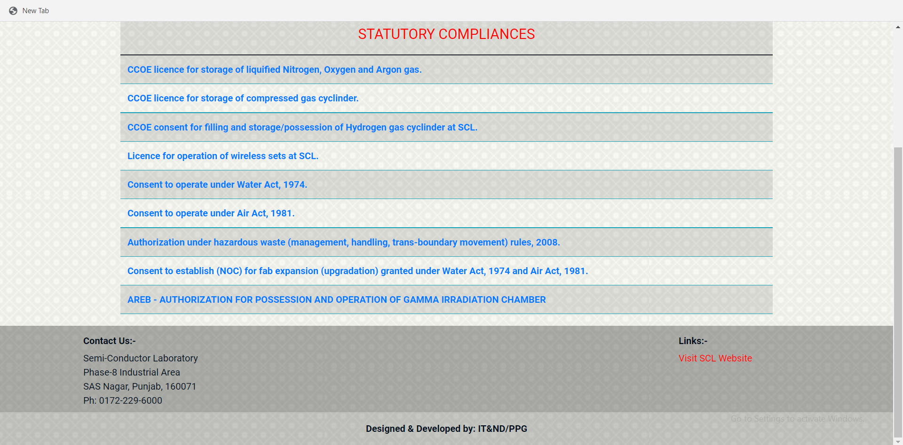4